Task-3 Subqueries & Analytical Queries
Task A (Exclusion): Find employees who had work on at least one project but not on ‘HR Automation’ project.
select e.employee_fname
from employee e
where not exists
(
select 1
from team t
join project p
on p.project_id = t.project_id
where p.project_name = 'HR Automation' and
t.team_id = e.team_id
);

Explanation:
This task identifies employees who have worked on at least one project but have never been assigned to the HR Automation project. It excludes employees associated with that specific project while ensuring they are involved in other project work.

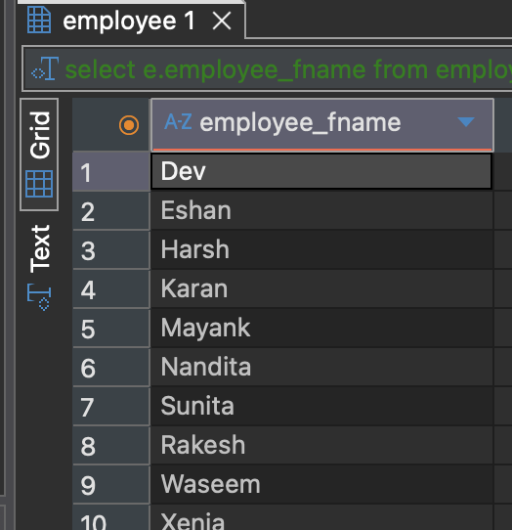

Task B (Pattern Matching): Find Projects which pattern ‘HR’ in it and employees working
on it.
select employee_fname
from employee
where team_id in (select team_id
from team where project_id in (
select project_id from project where project_name like '%HR%'));
Explanation:
This task finds projects whose names contain the pattern “HR” and lists the employees working on those projects. It uses pattern matching to filter relevant projects and links them to their assigned employees.

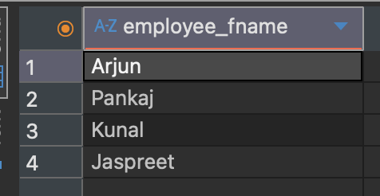

Task C (Range): Find employees joined between 2019 and 2021 using BETWEEN.
select employee_fname
from employee
where date_of_joining
between '2019-1-1' and '2021-1-1';
Explanation:
This task retrieves employees who joined the organization between the years 2019 and 2021. It uses a date range condition to filter employees based on their joining date.

